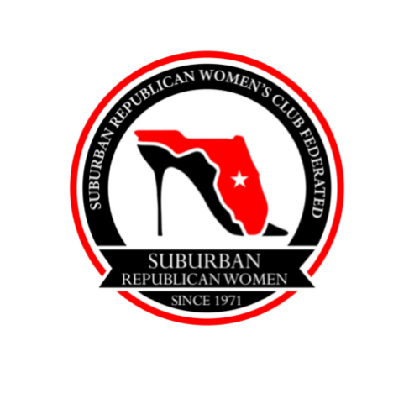
Suburban Republican Women’s Club Federated
Mildred Lind Leadership Scholarship Application

Deadline for Application: April 3, 2023
The Suburban Republican Women’s Club Federated awards a scholarship of $1,000 to a woman who has shown leadership and academic excellence in school and/or extracurricular activities.
Completed applications must be emailed to drtinacalderone@gmail.com or mailed to:
Tina Calderone
3353 Oakmont Terrace
Longwood, FL. 32779
Eligibility: Applicant must be a woman graduating from S.C.P.S. and be accepted into any accredited college, university or vocational technical school. She must have at least a 2.5 GPA and be a registered or pre- registered Republican in Seminole County.

____________________________________________________________________
Name Birthdate Mobile Phone

____________________________________________________________________
Address City Zip Code Email

_______________________________________________
Current school attending

_______________________________________________
College, university, or vocational school you plan to attend
Are you eligible for Bright Futures? _________________
Please submit the following with your completed application:
- High school transcript with SAT or ACT scores.
- A 100-200 word essay detailing your school and community activities, leadership roles and future goals, and any campaign activity involvement.
- Two letters of recommendation. (Please, no letters from family members.)

_______________________________________________________
Applicant Signature

